

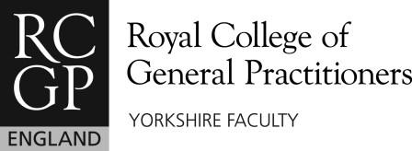
Press Release:
------------------------------------------------------------------------------------------------------------------------------------------------------
The Bradford
Exit Course
----------------------------------------------------------------------------------------------------------------------------------------------------
Thurs 8th & Fri 9th
March 2017
Hinsley Hall, Headingley Lane, Leeds, LS6 2BX
HURRY, HURRY, HURRY!
BOOK NOW BECAUSE THERE ARE ONLY 20 SPACES WHICH WILL BE GIVEN ON A FIRST COME, FIRST SERVED BASIS.

Course fee: £295
(most schemes will reimburse this from your Study Leave)

Course Organiser: Ramesh Mehay (of www.bradfordvts.co.uk )
Yorkshire RCGP presents:
THE BRADFORD EXIT COURSE
- The longest established Exit course in the country (10 years)
- Relaxed atmosphere
- Open to all GP trainees in their final 12 months from ANY scheme in the UK
- Bridges the gap between the real world of General Practice and what training schemes can provide (things you need to know but never prepared for)
- ‘One of the best courses ever’ according to previous attendees
- A much loved FREE comprehensive manual in which all the work is done for you!
- YOU KNOW this is THE COURSE for YOU.

What do we cover?
Learn all about partnerships and contracts.
We make finances and things like pensions, income protection, locum cover easy to understand.
Find out all the career choices available in primary care and how to strike a balance between them.
Learn about the reflective practitioner, revalidation, appraisal, educational portfolios and what it all means for you. We untangle it and help you find a way to make it easy.
Finally, we take you step by step through the process of becoming a locum.
…and of course, many other hot tips along the way.

IF INTERESTED: EMAIL FIONA LOWNDES on FLowndes@rcgp.org.uk or TEL: 01925 241995
OR CAL

